Thank you for your interest in the West Palm Beach Community Redevelopment Agency’s Lot 23 Housing Program.

Staff encourages you to carefully review this application to obtain a clear understanding of program participation and requirements. Should you desire to apply for the program, please complete and submit this application in accordance with the instructions outlined below.

INSTRUCTIONS

1. Review Section I – Program Overview (pages 2-3) portion of the application.

2. Complete Section II – Applicant and Household Information (pages 4-7) portion of the application.

3. Complete and attach copies of all requested documentation the Section III- Required Documents (page 8) of the application.

4. Authorize application submission by signing the space at the bottom of this page.

5. Contact Elise Liftin at the West Palm Beach Community Redevelopment Agency at 561-822-1409 or eliftin@wpb.org to submit or help with submitting your application.

If you have additional questions regarding this application or general questions, feel free to contact the Community Redevelopment Agency at:
City of West Palm Beach
Community Redevelopment Agency
401 Clematis Street – 2nd Floor
West Palm Beach, FL 33401
(561) 822-1550
http://wpb.org/cra

______________________________ _________________________ ___________________
Signature of Applicant Print Name Date

_____________________________ _________________________ ___________________
Signature of Co-Applicant Print Name Date

I hereby certify that all statements I have provided in this application and in the attachments herein are true; that I am authorized to sign this application and to make these statements, and that the organization understands that misrepresentation of any facts which lead to the improper allocation and expenditure of public funds may result in legal action against the organization for retrieval of any such funds and appropriate penalties.

Section I -

Program Overview

Introduction

The Lot 23 Housing Program is designed to provide the availability of safe and sanitary rental housing units at an affordable rate to eligible households.

Application Process

CRA will advertise availability of the units. Applications will be processed on a first-come, first-served basis, first-ready eligible basis from all applicant(s) meeting program eligibility criteria, subject to availability.

Applications will be made available online at wpb.org/CRA.

If you have additional questions, please email Elise Liftin at eliftin@wpb.org or call at 561-822-1409.

Only completed applications, which consists of a completed application form and all the applicable supporting documentation, will be accepted. No copies or exceptions will be made. If application is not completed, applicant(s) will have to schedule another appointment to submit application. Failure to provide all mandatory documentation can result in disqualification of application.

Maximum Income Limits and Maximum Rents Established

- Applicant(s) gross annual income shall be no more than 80% of the Area Median Income (AMI) limits established annually by the Florida Housing Finance Corporation (FHFC) for Multifamily Rental Programs.

- The amount the CRA will charge as rent for any of the unit shall be governed by the maximum rent imitations by FHFC based upon the number of rooms in the unit and the individual’s income. Rent shall be consistent with the rental calculation provided FCHC for Multifamily Rental Programs and as updated annually.

- We will be using 60%-80% AMI for the below schedule
Maximum Income Limit - Adjusted for Household Size
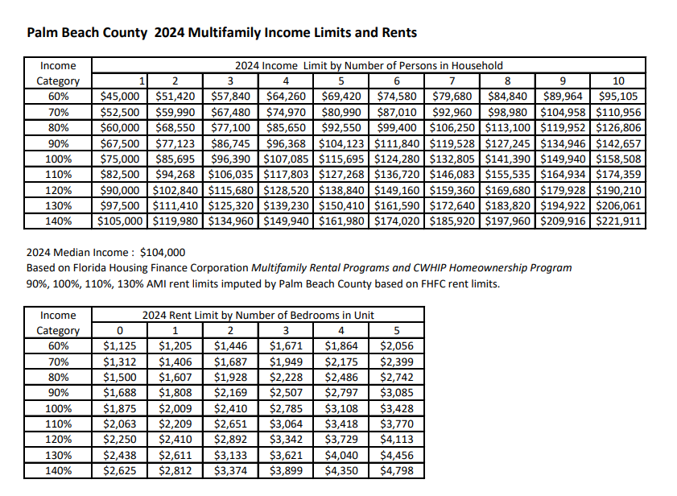

Income and Income Limits Effective 2024 and subject to change
Other Eligibility Criteria

- Applicant(s) must currently reside in the City of West Palm Beach and be a citizen of the United States or a permanent resident alien.
- Be 18 years of age or older.
- Have a gross annual household income (not to include the income of minors) which does not exceed 80% AMI as established by the chart above.
- Meet all other leasing criteria required by the CRA.

Determining Income Eligibility

The requirements for determining whether a household is eligible requires the CRA to project or estimate the annual income that the household expects to receive.

Tenants shall provide four (4) most recent pay stubs or earnings statements for all household members over the age of 18 showing the employees name, gross pay per pay period, deductions, and frequency of pay. The CRA shall convert the reported income to an annual figure by taking an average of the gross salary reported in the paystubs and multiplying:

- Weekly wages by 52;
- Bi-weekly wages (paid every other week) by 26;
- Semi-monthly wages (paid twice each month) by 24; and
- Monthly wages by 12.

Self-Employment tenant’s income shall be reported by accountant or bookkeeper’s statement of net income expected for the next 12 months printed on the accountant/book keeper’s company letterhead ; or a notarized, sworn statement, from the self-employed individual, of net income expected for the next 12 months.

If a household member receives Social Security, Supplemental Security Income (SSI), and/or Disability benefits., an annual award or benefit notification letter prepared and signed by the authorizing agency shall be provided.

Unemployed household members over the age of 18 shall provide a notarized, sworn statement from the household member stating that unemployment benefits are not received and he/or she is not receiving any income.

The CRA shall determine the household’s annual income by adding all the sources of income for all members over the age of 18 and converting the reported income into an annual figure.

Public Records Disclosure

Information provided by the applicant may be subject to Chapter 119, Florida Statutes regarding Open Records. Information provided by you that is not protected by Florida Statutes can be requested by any individual for their review and/or use. This is without regard as to whether or not you qualify for funding under the program(s) for which you are applying.

Notice of Collecting Social Security Number

The City collects your social security number for a number of different purposes. The Florida Public Records Law (specifically, section 119.071(5), Florida Statutes (2007), requires the City to give you this written statement explaining the purpose and authority for collecting your social security number.

Your Social Security Number is being collected for the purposes of income certifying you for the CRA’s Program which requires third-party verification of assets, employment and income. In addition, this information may be collected to verify unemployment benefits, social security/disability benefits and other related information necessary to determine income and assets and your eligibility for the program that is funded by local, Federal and/or State program dollars. Your social security number will not be used for any other intended purpose other than verifying your eligibility for the CRA’s program.

Section II - Applicant and Household Information

Household Information – Complete all sections.
Household Information
Household Size |  |  | Anticipated Gross Annual Household Income
Applicant Information
First Name |  | Last Name
Street Address |  | City |  |  | ST | Zip
Home Phone Number |  | Cell Phone Number |  |  |  | Social Security Number
 |  |  |  |  |  | xxx-xx - _________
Marital Status |  | Date of Birth |  |  |  | Employment Status
- Single  - Married  - Divorced  - Separated |  | _____/______/______ |  |  |  | - Employed  - Unemployed  - Retired  - Disabled
Co - Applicant Information
First Name |  | Last Name
Street Address |  | City |  |  | ST | Zip
Home Phone Number |  | Cell Phone Number |  |  |  | Social Security Number
 |  |  |  |  |  | xxx-xx - _________
Marital Status |  | Date of Birth |  |  |  | Employment Status
- Single  - Married  - Divorced  - Separated |  | _____/______/______ |  |  |  | - Employed  - Unemployed  - Retired  - Disabled
Complete for all other Household Members residing in Property
Household Member (First Name, Last Name) | Date of Birth |  |  | Relationship |  |  | Social Security Number
 |  |  |  |  |  |  | xxx-xx - _________
 |  |  |  |  |  |  | xxx-xx - _________
 |  |  |  |  |  |  | xxx-xx - _________
 |  |  |  |  |  |  | xxx-xx - _________
 |  |  |  |  |  |  | xxx-xx - _________
 |  |  |  |  |  |  | xxx-xx - _________

Employer Information – Complete for all Employed Household Members over the age of 18. Attach additional sheets if needed.
Employer Information
Employee First Name | Employee Last Name
Employer Name & Street Address | City/State | Zip | Telephone Number
Occupation | Years Employed |  | Name of Supervisor
Employer Information
Employee First Name | Employee Last Name
Employer Name & Street Address | City/State | Zip | Telephone Number
Occupation | Years Employed |  | Name of Supervisor
Employer Information
Employee First Name | Employee Last Name
Employer Name & Street Address | City/State | Zip | Telephone Number
Occupation | Years Employed |  | Name of Supervisor
Employer Information
Employee First Name | Employee Last Name
Employer Name & Street Address | City/State | Zip | Telephone Number
Occupation | Years Employed |  | Name of Supervisor
Employer Information
Employee First Name | Employee Last Name
Employer Name & Street Address | City/State | Zip | Telephone Number
Occupation | Years Employed |  | Name of Supervisor

Conflict of Interest Disclosure

In accordance with 24 CFR 570.611 applicants can be denied participation in the Lot 23 Housing Program if a conflict of interest exists. A conflict of interest exists if an applicant is an employee, agent, consultant, officer, elected official or appointed official of the recipient or subrecipients and the applicant currently or within the past 12 months:

- Exercises or has exercised any functions or responsibilities with respect to funds for this program.
- Participates or has participated in the decision-making process related to funds for this program.
- Is or was in a position to gain inside information with regard to program activities.

A conflict of interest may also arise if an applicant for assistance is related by family or has business ties to any employee, officer, elected or appointed official or agent of a unit of local government who exercises any functions or responsibilities with respect to the Lot 23 Housing Program . When a conflict of interest or perceived conflict of interest exists, the applicant must acknowledge the conflict.

Please read statement #1 and #2 and check the statement that applies to you.

_____1. A conflict of interest DOES NOT EXIST as it relates to the Lot 23 Housing Program.

_____2. A conflict of interest DOES EXIST as it relates to the Lot 23 Housing Program.

If you placed a checkmark by statement, #2 please explain the Conflict of Interest: ____________________________________________________________________________________________________________________________________________________________________________________________________________________________________________________________________________________________________________________________________

Certification Statements

_________The applicant(s) certifies that all information provided in this application and all information furnished in support of this application (including the asset, liability, and insurance disclosure forms attached hereto) is provide for the purpose of obtaining housing rehabilitation assistance and is true correct, and complete to the best of the applicant’s knowledge and belief.

________The applicant(s) understands that information in this application will be used to determine if the applicant is eligible for assistance and the amount of housing rehabilitation assistance to be provided. Applicant(s) understand(s) that the information provided is needed to determine assistance eligibility and in no way assures qualification for assistance. The applicant(s) also agrees to provide any other documentation needed to verify eligibility.

WARNING: Section 1001 of Title 19 of the U.S. code makes it a criminal offense to make willful false statements or misrepresentation to any department or agency of the United States as to any matter within jurisdiction. The information provided in this application is true and correct as of the date set forth opposite my signature and that may intentional or negligent misrepresentation of this information contained in the application may result in civil liability, and /or in criminal penalties including, but not limited to, fine or imprisonment or both.

______________________________ _________________________ ___________________
Signature of Applicant Print Name Date

_____________________________ _________________________ ___________________
Signature of Co-Applicant Print Name Date

Authorization for Release of Information - Complete for all Household Members over the age of 18.

I , the undersigned, hereby authorize release without liability, information regarding my/our employment income, and/or assets to West Palm Beach Community Redevelopment Agency for the purposes of verifying information provided, as part of determining eligibility for assistance under the Lot 23 Housing Program. I understand that only information necessary for determining eligibility can be requested.

Types of information to be verified:

Verifications that may be requested are, but not limited to: personal identify; employment history, hours worked, salary and payment frequency, commissions, raises, bonuses, and tips; cash held in checking/savings accounts, stocks, bonds, certificate of deposits (CD), Individual Retirement Accounts (IRA), interest, dividends, etc.; payments from Social Security, annuities, insurance policies, retirement funds, pensions disability or death benefits; unemployment, disability and/or worker’s compensation; welfare assistance; net income from the operation of a business; and, alimony or child support payments, etc.

Criminal background checks will be performed to determine eligibility.

Organizations/Individuals that maybe asked to provide written/oral verification are, but not limited to:

Past/Present Employers Alimony/Child/Other Support Providers
Banks, Financial or Retirement Institutions Social Security Administration
State Unemployment Agency Veterans Administration
Welfare Agency

Agreement to Conditions

I agree that a photocopy of this authorization may be used for the purposes stated above. I understand that I have the right to review this file and correct any information found to be incorrect.

______________________________ _________________________ ___________________
Signature Print Name Date

NOTE: This general consent may not be used to request a copy of a tax return. If one is needed, contact your local IRS office for Form 4506. Request for Copy of Tax Return and prepare and sign separately.

Section III- Required Documents

The documents listed below must be submitted with your completed application, which consists of a completed application form AND all the applicable supporting documentation as listed below. Some of the requested information may not pertain you. Only provide the information that pertains to your household. Appropriate information will be verified by third-party. Only copies will be accepted.

- Proof of Income.

- Four (4) most recent pay stubs or earnings statements showing the employees name, gross pay per pay period, deductions, and frequency of pay for every household member over 18 years old.

- Self-Employment tenant’s income shall be reported by accountant or bookkeeper’s statement of net income expected for the next 12 months printed on the accountant/book keeper’s company letterhead ; or a notarized, sworn statement, from the self-employed individual, of net income expected for the next 12 months.

- If a household member over 18 receives Social Security, Supplemental Security Income (SSI), and/or Disability benefits., an annual award or benefit notification letter prepared and signed by the authorizing agency shall be provided.

- Unemployed household members over the age of 18 shall provide a notarized, sworn statement from the household member stating that unemployment benefits are not received and he/or she is not receiving any income.

- Social Security Cards. Social Security Cards for all household members. The City will review the original social security card; however, a copy will not be kept in the program file.

- Photo Identification. Provide photo ID for all household members over the age of 18.

- Proof of citizenship or legal alien status documents.

- United States of America birth certificate or
- Naturalization papers or
- Alien registration card

