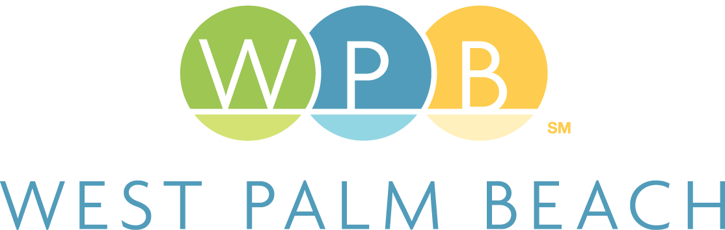

PY 2024
City of West Palm Beach

Department of Housing and Community Development

401 Clematis Street
West Palm Beach, FL 33401
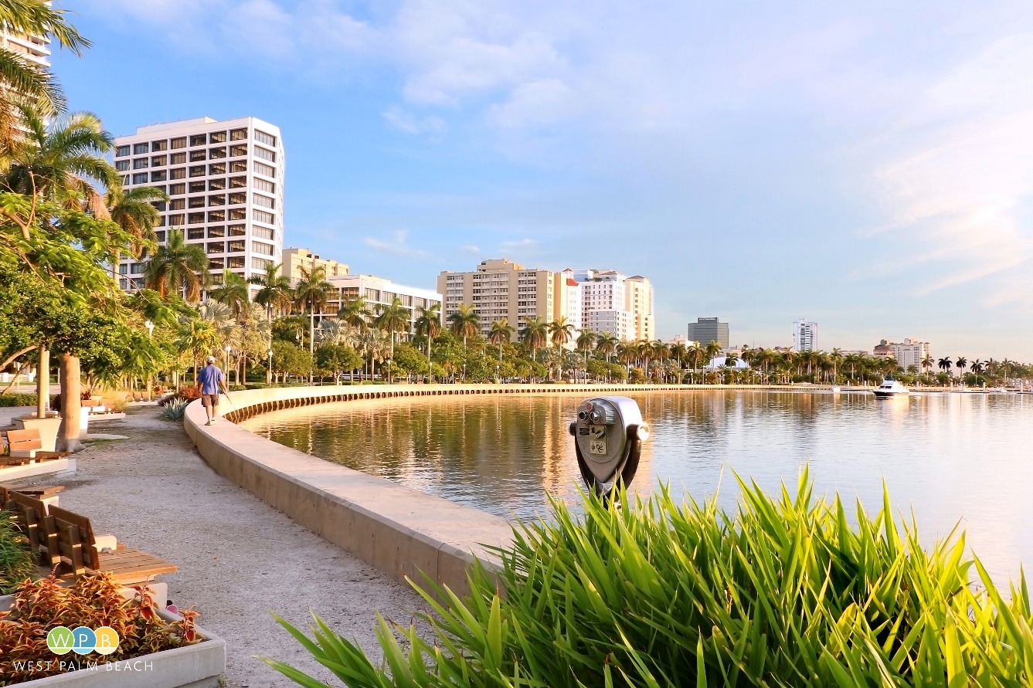
Hud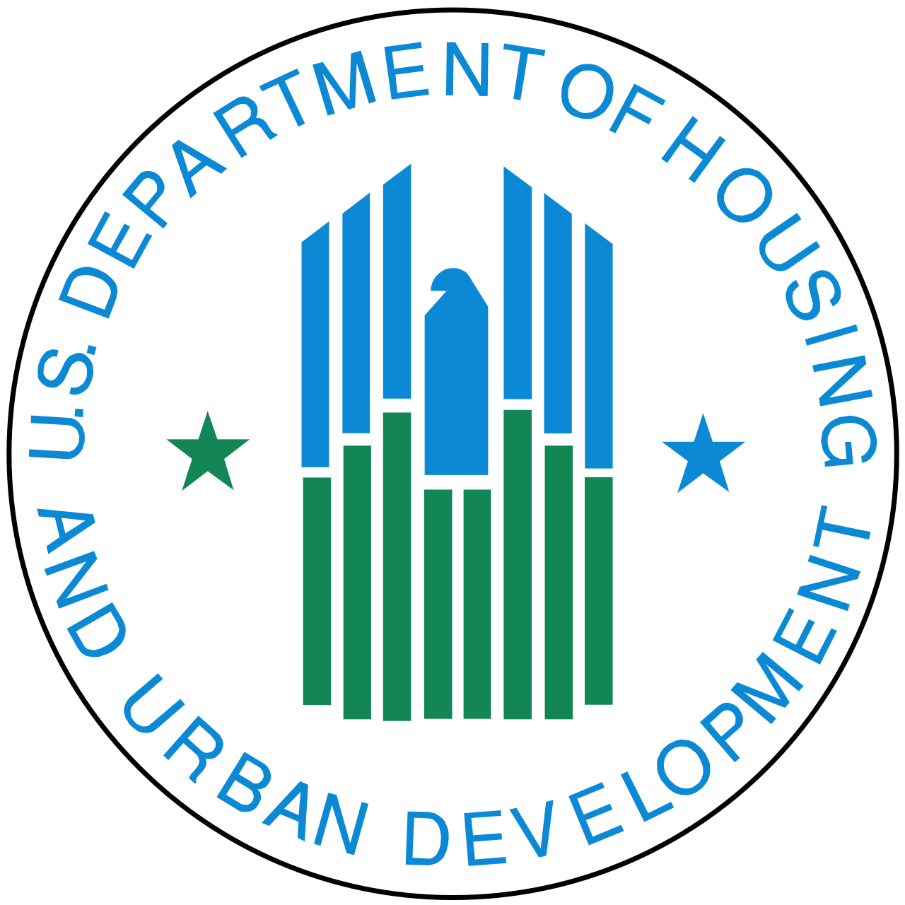 logo 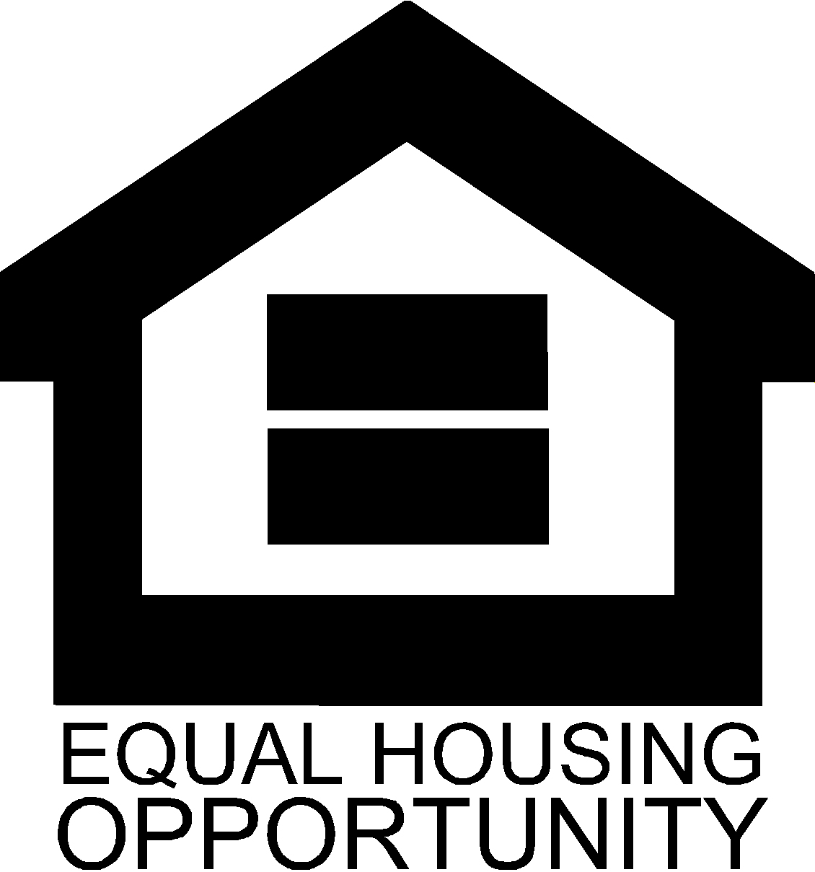 The Consolidated Plan is carried out through an annual Action Plan which provides a concise summary of the activities, projects, and specific federal and non-federal resources that will be used each year.
- This Plan covers the activities that will be undertaken during the FY 2024 program year October 1, 2024 – September 30, 2025.

Annual Action Plan
Table of Contents

Executive Summary 3
AP-05 Executive Summary - 24 CFR 91.200(c), 91.220(b) 3
PR-05 Lead & Responsible Agencies – 91.200(b) 6
AP-10 Consultation – 91.100, 91.200(b), 91.215(l) 7
AP-12 Participation – 91.105, 91.200(c) 20
Expected Resources 24
AP-15 Expected Resources – 91.220(c)(1,2) 24
Annual Goals and Objectives 28
Projects 31
AP-35 Projects – 91.220(d) 31
AP-38 Project Summary 32
AP-50 Geographic Distribution – 91.220(f) 37
Affordable Housing 41
AP-55 Affordable Housing – 91.220(g) 41
AP-60 Public Housing – 91.220(h) 43
AP-65 Homeless and Other Special Needs Activities – 91.220(i) 45
AP-70 HOPWA Goals– 91.220 (l)(3) 49
AP-75 Barriers to affordable housing – 91.220(j) 50
AP-85 Other Actions – 91.220(k) 52
Program Specific Requirements 56

Executive Summary

AP-05 Executive Summary - 24 CFR 91.200(c), 91.220(b)
- Introduction
The City of West Palm Beach’s Department of Housing and Community Development’s mission is to ensure quality of life for its residents through the development of housing, social, and economic opportunities. The Department is committed to high standards of customer service in the administration and delivery of programs that are collaborative, innovative, and sustainable.
Creating opportunities that will support and empower low-income households and neighborhoods requires a multifaceted and comprehensive approach. The City of West Palm Beach has determined that in order to maximize the production of affordable housing, economic development, and the provision of services and public infrastructure and facilities to its residents, it must commit to a variety of public/private initiatives and work towards integrative goals that focus on leveraging strategies both internally and across multiple City departments.
As an entitlement community receiving U.S. Department of Housing and Urban Development (HUD) formula program funds, the City of West Palm Beach is required to submit a Five-Year Consolidated Plan that serves as the planning tool outlining the jurisdiction’s housing and community development needs. The Consolidated Plan is carried out through annual Action Plans which provide a concise summary of the fiscal year’s activities, and specific federal and non-federal resources that will be used each year to develop strong, sustainable, and inclusive communities.
The participation of City residents, community stakeholders, and guidance of public employees enriched the planning process for this Action Plan and allowed the City to achieve a common vision and strategy for investments of annual allocations of Community Development Block Grant (CDBG), HOME Investment Partnerships Program (HOME), and Housing Opportunities for Persons with AIDS (HOPWA) program funds.
The Annual Action Plan is the application for receipt of federal funds and identifies projects and activities to be undertaken during the program year, October 1, 2024 – September 30, 2025. These projects and activities are established based on the priorities identified in the 2020-2024 Consolidated Plan. During PY 2024-2025, the City of West Palm Beach anticipates receiving federal grant funds totaling $5,201,323 under the following HUD programs: CDBG - $1,039,077; HOME - $492,244; and HOPWA- $3,670,002.
- Summarize the objectives and outcomes identified in the Plan
The Plan’s objectives and outcomes are based on the needs assessment and support HUD’s primary objectives under the formula programs, which include providing decent affordable housing, a suitable living environment, and economic opportunities for low to moderate income families and individuals.
The goals will be achieved through the performance framework of (1) availability/accessibility, (2) affordability, and (3) sustainability.
During PY 2024 - 2025, based on the needs assessment, the City will focus on the following activities:
- Provide funding for public facilities and improvements;
- Increase homeownership opportunities;
- Increase supply of affordable rental housing; and
- Provide housing and services to special needs populations with an emphasis on serving the homeless population.
3. Evaluation of past performance
The City’s Annual Action Plans and CAPERs (Consolidated Annual Performance and Evaluation Report) detail the City’s accomplishments in meeting the goals and priorities established in the Consolidated Plan. The City’s CAPERs may be viewed at: wpb.org/housing.
4. Summary of Citizen Participation Process and consultation process
The City of West Palm Beach’s Citizen Participation Plan is designed to ensure compliance with the HUD requirements for citizen participation in all appropriate HUD grant programs.
The City’s citizen participation process and consultation services included the following:
- One (1) public hearing meeting was held; meeting was advertised in a newspaper of major circulation, published on the City’s website, and announced at public meetings and forums.
- Staff met with stakeholders and attended local meetings and forums to educate residents on the consolidated planning process and encourage participation and input.
- The draft PY 2024 - 2025 Action Plan was made available to the public for review and comment between Saturday, June 22, 2024, and ended on Monday, July 22, 2024. The City published a notice in the Palm Beach Post on June 22, 2024, informing the public of the availability of the document for review and comment. The document was also posted on the City’s website.
5. Summary of public comments
Input gathered at a public meeting held on June 11, 2024, focused on the availability or need for mental health services for the City’s homeless population along with housing assistance including vouchers and rental assistance, the lack of affordable housing units, and housing rehabilitation programs for residents, especially for elderly homeowners.

6. Summary of comments or views not accepted and the reasons for not accepting them
All comments or views from residents and agencies will be accepted and incorporated into this Action Plan.
7. Summary
The City of West Palm Beach understands the importance of citizen participation in the Annual Action Plan process. Citizen participation and stakeholder consultation are key components of the Plan. A well-designed citizen participation and consultation strategy was used to:
- Gather input on priority needs and target areas
- Increase coordination among consultation partners
- Leverage Consolidated Plan activities with other public and private funding sources and programs
- Expand upon the outreach efforts of existing planning processes
- Increase citizen feedback, buy-in, and support of Action Plan activities
The citizen participation plan process provided important feedback from stakeholders and citizens and helped to shape the goals and objectives outlined in this Annual Action Plan.

PR-05 Lead & Responsible Agencies – 91.200(b)
1. Agency/entity responsible for preparing/administering the Consolidated Plan
Describe the agency/entity responsible for preparing the Consolidated Plan and those responsible for administration of each grant program and funding source.
Agency Role | Name | Department/Agency
CDBG Administrator | WEST PALM BEACH | Housing and Community Development
HOPWA Administrator | WEST PALM BEACH | Housing and Community Development
HOME Administrator | WEST PALM BEACH | Housing and Community Development

Table 1 – Responsible Agencies

Narrative (optional)
The City of West Palm Beach Department of Housing and Community Development is the lead agency responsible for the oversight and administration of the CDBG program, HOME program, and the HOPWA program. The City works with non-profit and other private sector organizations either as subrecipients, developers or CHDOs, and project sponsors for service delivery or housing activities under each program.
The City of West Palm Beach executes a written agreement with each agency that receives funding, and the City is responsible for monitoring all organizations that receive funding in accordance with the executed written agreement and the regulations that apply to the formula program.
Consolidated Plan Public Contact Information
Jennifer Ferriol, Director
Housing and Community Development
401 Clematis Street, Third Floor, West Palm Beach, FL 33401
(561) 822-1250 / JFerriol@wpb.org

AP-10 Consultation – 91.100, 91.200(b), 91.215(l)
- Introduction
As part of the Action Plan development process, federal regulations (24 CFR 91.200(b), 91.215(i)) require that a jurisdiction consult extensively with community service providers, other jurisdictions, and other entities with a potential interest in or knowledge of that jurisdiction’s housing, homeless, non-housing special needs, and non-housing community development issues. For PY 2024-2025, the City continued to provide a forum for open communication with key stakeholders regarding its HUD funded programs.
Provide a concise summary of the jurisdiction’s activities to enhance coordination between public and assisted housing providers and private and governmental health, mental health and service agencies (91.215(l))
The City of West Palm Beach regularly consults with both public and private agencies in the development of this Plan and all HUD funded initiatives. The City staff serves on the board of several committees organized by stakeholders and vice versa and participates in regularly scheduled neighborhood outreach meetings. This includes active participation in regularly scheduled neighborhood association meetings, Homeless Continuum of Care meetings, and committees and subcommittees whose main objective is affordable housing. This provides open lines of communication for both the City and stakeholders to keep abreast of existing or proposed activities and programs that serve the community, allows the City and stakeholders to provide support and input of proposed activities, and helps to reduce duplication of efforts. This also helps to identify unmet needs in the community. Also, by serving on these boards and encouraging participation of stakeholders in City committees, boards and meetings, the City continues to maintain a working relationship with these organizations. The open communication with these groups helps to develop and encourage partnerships that may leverage funds for planned and future programs, projects or developments. The City is an active participant in the following committees:
- Care Council;
- Housing and Homeless Alliance;
- Housing Leadership Council;
- Affordable Housing Collaborative;
- Workforce Housing Steering Committee;
- Frequent User System Engagement (FUSE) Steering Committee;
- Re-entry Taskforce and Re-entry Housing Sub-Committee;
- Florida Housing Coalition;
- Childnet; and
- Community Action Agency Advisory Board.

Describe coordination with the Continuum of Care and efforts to address the needs of homeless persons (particularly chronically homeless individuals and families, families with children, veterans, and unaccompanied youth) and persons at risk of homelessness.
The City of West Palm Beach works closely with the Homeless and Housing Alliance (HHA) of Palm Beach County (the Continuum of Care lead agency) whose main function is to deliver a comprehensive and coordinated continuum of services for homeless individuals and families, families with children, veterans and unaccompanied youth. This system’s fundamental components include homeless prevention, outreach and assessment, emergency shelter, transitional housing, supportive services, permanent housing, and permanent supportive housing. The HHA includes community-based membership with representatives from government, business, formerly homeless individuals, law enforcement, banking, housing service providers, faith groups, education, veterans, health care, and concerned individuals. Palm Beach County Division of Human Services (the Division) continues its role as the lead entity for the HHA.
The City of West Palm Beach, through its Community Services Division, provides a front line of contact for many people who are experiencing or at risk of homelessness, referring them to the Senator Philip D. Lewis Homeless Resource Center and/or mainstream support services, as appropriate. The City recently increased its Community Services staff to add a new position, Social Services Supervisor, that will be responsible for overseeing the homeless outreach team and making referrals to long-term and short-term crisis-oriented psychotherapy.
The City supports the efforts of the HHA through direct delivery of programs for the homeless including providing permanent housing, Rapid Rehousing, the Homeward Bound Program to assist with relocation and through referrals to support service providers. Through its Housing Stabilization Program, the City also provides one-time funding assistance of up to $7,500 for eligible applicants facing evictions or experiencing homelessness to obtain safe, decent and affordable rental housing.
The City in partnership with Palm Beach County’s Division of Human Services and Community Action (HSCA) applied for federal funding through the FY 2022 Continuum of Care (CoC) Program Competition. HSCA oversees the annual U.S. Department of Housing and Urban Development (HUD) CoC competition and serves as the Collaborative Applicant for HHA. The City of West Palm Beach will serve as a project subrecipient with the Housing and Community Development Department responsible for administering the project. The project, The Pathway to Independence Program was awarded $482,117 to provide housing assistance and supportive services, including rental assistance, utility deposits, and case management, to chronically homeless individuals.

Describe consultation with the Continuum(s) of Care that serves the jurisdiction's area in determining how to allocate ESG funds, develop performance standards for and evaluate outcomes of projects and activities assisted by ESG funds, and develop funding, policies and procedures for the operation and administration of HMIS
Although the City does not administer ESG funding, it supports efforts to house and provide support services to the homeless. Through participation in the Continuum of Care administered by the Palm Beach County Human Services Homeless and Housing Alliance, the City is able to participate in and stay informed of the Countywide efforts to end homelessness. This organization has developed performance standards for coordinated intake and assessment, adopting housing first core concepts, implementing housing first standards, and establishing core components for rapid rehousing and procedures for HMIS administration. The City actively participates in policy meetings and initiatives and is one of the lead entities for the Frequent User System Engagement (FUSE) pilot and for housing programs for those re-entering from the justice system.
By attending board meetings and events, receiving updates provided on the website, and maintaining open channels of communication, the City of West Palm Beach can better plan and work with the Continuum of Care in the goal of preventing and ending homelessness for vulnerable residents. Some recent efforts have included providing City owned properties for supportive housing, providing funding preferences for supportive housing projects and programs that serve the homeless and assisting with coordinated intake and assessment of homeless individuals through the Community Services Division. Services to the homeless population provided by the City’s Community Service Division are also entered into HMIS and those services are coordinated with other homeless providers.
2. Describe Agencies, groups, organizations and others who participated in the process and describe the jurisdiction’s consultations with housing, social service agencies and other entities

1 | Agency/Group/Organization | Housing Leadership Council of Palm Beach County
1 | Agency/Group/Organization Type | Housing  Services - Housing  Service-Fair Housing  Neighborhood Organization
1 | What section of the Plan was addressed by Consultation? | Housing Need Assessment  Homeless Needs - Chronically homeless  Homeless Needs - Families with children  Homelessness Needs - Veterans  Homelessness Needs - Unaccompanied youth  Homelessness Strategy  Non-Homeless Special Needs
1 | Briefly describe how the Agency/Group/Organization was consulted. What are the anticipated outcomes of the consultation or areas for improved coordination? | The City of West Palm Beach regularly consults with both public and private agencies in the development of this Plan and all HUD funded initiatives. Through on-going meetings and continuous collaboration, the City of West Palm Beach is able to obtain input from service providers, housing agencies, and social services agencies who currently provide services or who want to provide services to the residents of the City of West Palm Beach. The City also is a member of and regular participant in committees and forums that are related to housing and social services including the HIV/AIDS Care Council, Homeless and Housing Alliance and Community Action Agency. The City received input and participation from entities who are a part of the various committees and initiatives the City participates in. Those agencies included the West Palm Beach and Palm Beach County Housing Authorities, Palm Beach County Department of Housing and Economic Sustainability, Palm Beach County Department of Human Services, Palm Beach County Criminal Justice Commission and various non-profit entities that make up the Continuum of Care.
2 | Agency/Group/Organization | Florida Housing Coalition
2 | Agency/Group/Organization Type | Housing  Service-Fair Housing
2 | What section of the Plan was addressed by Consultation? | Housing Need Assessment  Public Housing Needs  Homeless Needs - Chronically homeless  Homeless Needs - Families with children  Homelessness Needs - Veterans  Homelessness Needs - Unaccompanied youth  Homelessness Strategy  Non-Homeless Special Needs  Economic Development  Lead-based Paint Strategy
2 | Briefly describe how the Agency/Group/Organization was consulted. What are the anticipated outcomes of the consultation or areas for improved coordination? | The City continues to maintain the lines of communication open between non-profit and for-profit organizations, the local government, county government, state and federal agencies. The needs that exist within the City cannot be addressed with the limited funding available. By working in partnership with other organizations who have a vested interest in serving very low- and low-income residents, we can provide a comprehensive approach to an array of services to better meet the needs of individuals and families.
3 | Agency/Group/Organization | Homeless and Housing Alliance of Palm Beach County
3 | Agency/Group/Organization Type | Housing  Services - Housing  Services-Persons with Disabilities  Services-Persons with HIV/AIDS  Services-homeless  Services-Health  Services-Education
3 | What section of the Plan was addressed by Consultation? | Homeless Needs - Chronically homeless  Homeless Needs - Families with children  Homelessness Needs - Veterans  Homelessness Needs - Unaccompanied youth  Homelessness Strategy
3 | Briefly describe how the Agency/Group/Organization was consulted. What are the anticipated outcomes of the consultation or areas for improved coordination? | The City continues to maintain the lines of communication open between non-profit and for-profit organizations, the local government, county government, state and federal agencies. The needs that exist within the City cannot be addressed with the limited funding available. By working in partnership with other organizations who have a vested interest in serving very low- and low-income residents, we can provide a comprehensive approach to an array of services to better meet the needs of individuals and families.
4 | Agency/Group/Organization | West Palm Beach Housing Authority
4 | Agency/Group/Organization Type | Housing  PHA  Services - Housing  Services-Elderly Persons  Services-Persons with Disabilities  Services-Persons with HIV/AIDS  Service-Fair Housing
4 | What section of the Plan was addressed by Consultation? | Housing Need Assessment  Public Housing Needs  Homelessness Strategy  Anti-poverty Strategy
4 | Briefly describe how the Agency/Group/Organization was consulted. What are the anticipated outcomes of the consultation or areas for improved coordination? | The City continues to maintain the lines of communication open between non-profit and for-profit organizations, the local government, county government, state and federal agencies. The needs that exist within the City cannot be addressed with the limited funding available. By working in partnership with other organizations who have a vested interest in serving very low- and low-income residents, we can provide a comprehensive approach to an array of services to better meet the needs of individuals and families.
5 | Agency/Group/Organization | Palm Beach County Housing Authority
5 | Agency/Group/Organization Type | Housing  PHA  Services - Housing  Services-Persons with HIV/AIDS  Services-homeless  Services-Education  Services-Employment  Service-Fair Housing
5 | What section of the Plan was addressed by Consultation? | Public Housing Needs  HOPWA Strategy
5 | Briefly describe how the Agency/Group/Organization was consulted. What are the anticipated outcomes of the consultation or areas for improved coordination? | The City continues to maintain the lines of communication open between non-profit and for-profit organizations, the local government, county government, state and federal agencies. The needs that exist within the City cannot be addressed with the limited funding available. By working in partnership with other organizations who have a vested interest in serving very low- and low-income residents, we can provide a comprehensive approach to an array of services to better meet the needs of individuals and families.
6 | Agency/Group/Organization | PBC HIV Care Council
6 | Agency/Group/Organization Type | Housing  Services - Housing  Services-Children  Services-Elderly Persons  Services-Persons with Disabilities  Services-Persons with HIV/AIDS  Services-Victims of Domestic Violence  Services-homeless  Services-Health  Services-Education  Services-Employment  Child Welfare Agency  Other government - County
6 | What section of the Plan was addressed by Consultation? | HOPWA Strategy
6 | Briefly describe how the Agency/Group/Organization was consulted. What are the anticipated outcomes of the consultation or areas for improved coordination? | The City continues to maintain the lines of communication open between non-profit and for-profit organizations, the local government, county government, state and federal agencies. The needs that exist within the City cannot be addressed with the limited funding available. By working in partnership with other organizations who have a vested interest in serving very low- and low-income residents, we can provide a comprehensive approach to an array of services to better meet the needs of individuals and families.
7 | Agency/Group/Organization | Palm Beach County Department of Economic Sustainability
7 | Agency/Group/Organization Type | Services - Victims  Other government - County
7 | What section of the Plan was addressed by Consultation? | Lead-based Paint Strategy
7 | Briefly describe how the Agency/Group/Organization was consulted. What are the anticipated outcomes of the consultation or areas for improved coordination? | The City continues to maintain the lines of communication open between non-profit and for-profit organizations, the local government, county government, state and federal agencies. The needs that exist within the City cannot be addressed with the limited funding available. By working in partnership with other organizations who have a vested interest in serving very low- and low-income residents, we can provide a comprehensive approach to an array of services to better meet the needs of individuals and families.
8 | Agency/Group/Organization | The Lord's Place
8 | Agency/Group/Organization Type | Housing  Services - Housing  Services-Children  Services-Elderly Persons  Services-Persons with Disabilities  Services-Persons with HIV/AIDS  Services-Victims of Domestic Violence  Services-homeless  Services-Health  Services-Education  Service-Fair Housing  Services - Victims
8 | What section of the Plan was addressed by Consultation? | Homeless Needs - Chronically homeless  Homeless Needs - Families with children  Homelessness Needs - Veterans  Homelessness Needs - Unaccompanied youth  Homelessness Strategy
8 | Briefly describe how the Agency/Group/Organization was consulted. What are the anticipated outcomes of the consultation or areas for improved coordination? | The City continues to maintain the lines of communication open between non-profit and for-profit organizations, the local government, county government, state and federal agencies. The needs that exist within the City cannot be addressed with the limited funding available. By working in partnership with other organizations who have a vested interest in serving very low- and low-income residents, we can provide a comprehensive approach to an array of services to better meet the needs of individuals and families.
9 | Agency/Group/Organization | Neighborhood Renaissance, Inc.
9 | Agency/Group/Organization Type | Housing  Services - Housing
9 | What section of the Plan was addressed by Consultation? | Housing Need Assessment  Market Analysis  Anti-poverty Strategy
9 | Briefly describe how the Agency/Group/Organization was consulted. What are the anticipated outcomes of the consultation or areas for improved coordination? | The City continues to maintain the lines of communication open between non-profit and for-profit organizations, the local government, county government, state and federal agencies. The needs that exist within the City cannot be addressed with the limited funding available. By working in partnership with other organizations who have a vested interest in serving very low- and low-income residents, we can provide a comprehensive approach to an array of services to better meet the needs of individuals and families.
10 | Agency/Group/Organization | Northend RISE
10 | Agency/Group/Organization Type | Housing  Services - Housing  Services-Children  Services-Elderly Persons  Services-Persons with Disabilities  Services-homeless  Services-Health  Services-Education  Services-Employment  Neighborhood Organization
10 | What section of the Plan was addressed by Consultation? | Housing Need Assessment  Non-Homeless Special Needs  Market Analysis  Anti-poverty Strategy  Non-housing Community Development Strategy
10 | Briefly describe how the Agency/Group/Organization was consulted. What are the anticipated outcomes of the consultation or areas for improved coordination? | The City continues to maintain the lines of communication open between non-profit and for-profit organizations, the local government, county government, state and federal agencies. The needs that exist within the City cannot be addressed with the limited funding available. By working in partnership with other organizations who have a vested interest in serving very low- and low-income residents, we can provide a comprehensive approach to an array of services to better meet the needs of individuals and families.
11 | Agency/Group/Organization | The Urban League Of Palm Beach County
11 | Agency/Group/Organization Type | Housing  Services - Housing  Services-Children  Services-Elderly Persons  Services-Persons with Disabilities  Services-homeless  Services-Health  Services-Education  Services-Employment
11 | What section of the Plan was addressed by Consultation? | Housing Need Assessment  Non-Homeless Special Needs  Market Analysis  Anti-poverty Strategy
11 | Briefly describe how the Agency/Group/Organization was consulted. What are the anticipated outcomes of the consultation or areas for improved coordination? | The City continues to maintain the lines of communication open between non-profit and for-profit organizations, the local government, county government, state and federal agencies. The needs that exist within the City cannot be addressed with the limited funding available. By working in partnership with other organizations who have a vested interest in serving very low- and low-income residents, we can provide a comprehensive approach to an array of services to better meet the needs of individuals and families.
Table 2 – Agencies, groups, organizations who participated

Identify any Agency Types not consulted and provide rationale for not consulting
There were no agency types that were not consulted. Through the use of outreach, all agencies and agency types were given an opportunity to comment and provide input.

Other local/regional/state/federal planning efforts considered when preparing the Plan
Name of Plan | Lead Organization | How do the goals of your Strategic Plan overlap with the goals of each plan?
Leading the Way Home Palm Beach County | Homeless and Housing Alliance | Addressing homelessness is a goal in the City’s Consolidated Plan and Annual Action Plan. Leading the Way Home focuses on the development of a coordinated service delivery system to ensure that every homeless person is housed/sheltered.
Housing for All | Housing Leadership Council of Palm Beach County | Providing affordable housing is consistent with the Housing for All plan which focuses on how to achieve a significant increase in workforce and affordable housing for a broad range of incomes.
Table 3 – Other local / regional / federal planning efforts
Narrative (optional)
The City of West Palm Beach maintains open and consistent communication and coordination with Palm Beach County in the implementation of its programs. The County, through its Department of Housing and Economic Sustainability and Department of Human Services, has an array of housing, community development and public service programs that help to enhance the current services and programs available through the City. The City is kept up to date by participating and attending meetings and forums, meeting with County leadership, development of joint projects, and by regularly reviewing the availability of information published on the county’s website.
The State of Florida provides several programs and services that help to enhance those provided by the City that are made available to assist residents. Through the Florida Housing Finance Corporation, the Florida Housing Coalition, and the Florida Commerce, residents and non-profit organizations can receive training and technical assistance and learn about programs and services available to residents. The City also receives funding for affordable housing activities from the State that combined with the technical assistance resources is used to leverage funding for programs, increase participation, and learn about services available to local organizations, service providers and residents.
One of the priorities of the City of West Palm Beach is to ensure that we are working with all stakeholders in carrying out the Strategic Plan and the Action Plan. The City has actively participated with the County and other municipalities in reviewing and developing policies and strategies for affordable and workforce housing development. Within that framework the City was able to receive feedback on potential new strategies that could be incorporated into the implementation of the Consolidated Plan. The City will continue to maintain the lines of communication open between non-profit and for-profit organizations, the local government, county government, state, and federal agencies. The needs that exist within the City cannot be addressed with the limited funding available. By working in partnership with other organizations who have a vested interest in serving very low- and low-income residents, we can provide a comprehensive approach to an array of services to better meet the needs of individuals and families.

AP-12 Participation – 91.105, 91.200(c)
1. Summary of citizen participation process/Efforts made to broaden citizen participation
Summarize citizen participation process and how it impacted goal-setting
The City of West Palm Beach engages in ongoing activities to involve citizens and stakeholders in the development of the Action Plan. The City of West Palm Beach’s Citizen Participation Plan is designed to ensure compliance with the HUD requirements for citizen participation in all appropriate HUD grant programs.
In conjunction with the PY 2024-25 Action Plan, the City’s citizen participation process and consultation services included the outreach efforts outlined below:
The City conducted its annual Needs Assessment Public Meeting to determine the nature and types of assistance needed to address the City’s priority needs. The meeting was held on June 11, 2024, in-person and virtually, via Zoom, to encourage maximum participation.
The draft PY 2024 -2025 Action Plan was made available to the public for review and comment between Saturday, June 22, 2024, and ended on Monday, July 22, 2024. The City published a notice in the Palm Beach Post on June 22, 2024, informing the public of the availability of the document for review and comment.
The Action Plan draft document was made available for viewing on the City’s website at www.wpb.org/housing and at the following location: City of West Palm Beach Department of Housing and Community Development, 401 Clematis Street, West Palm Beach, FL 33401. All interested parties were invited to submit written comments to be considered before going to the City Commission for approval. Written comments could be mailed or submitted via email. The City held a public hearing on July 22, 2024, where the Plan was considered and approved by the City Commission.

Citizen Participation Outreach

Sort Order | Mode of Outreach | Target of Outreach | Summary of  response/attendance | Summary of  comments received | Summary of comments not accepted and reasons | URL (If applicable)
1 | Public Meeting | Minorities  Non-English speaking persons: Spanish  Persons with disabilities  Non-targeted/broad community  Residents of Public/Assisted Housing | 6 Members of the public attended the meeting | Availability/need for mental health/homeless programs including vouchers and rental assistance.  Availability/need of affordable housing units.  Homeownership rehabilitation, especially for elderly homeowners. | N/A | www.wpb.org/housing
2 | Internet Outreach | Minorities  Non-English speaking persons: Spanish  Persons with disabilities  Non-targeted/broad community  Residents of Public/Assisted Housing | N/A | None | N/A | http://wpb.org/housing
3 | Newspaper Ad | Minorities  Non-English speaking persons: Spanish  Persons with disabilities  Non-targeted/broad community  Residents of Public/Assisted Housing | N/A | None | N/A | N/A
4 | Public Hearing | Minorities  Non-English speaking persons: Spanish  Persons with disabilities  Non-targeted/broad community  Residents of Public/Assisted Housing |  |  |  | N/A

Table 4 – Citizen Participation Outreach

Expected Resources

AP-15 Expected Resources – 91.220(c)(1,2)
Introduction
During PY 2024-2025 (October 1, 2024 – September 30, 2025), the City of West Palm Beach anticipates receiving federal grant funds totaling $5,201,323 from HUD through the CDBG, HOME, and HOPWA programs. Over the course of the program year, the City will also have available unexpended funds from prior years and may generate CDBG and HOME program income, primarily from the repayment of default mortgages. Prior years resources available to commit are as follows: CDBG - $1,289,316; CDBG-CV - $49,088; HOME - $1,765,722; HOME-ARP - $1,474,118; and HOPWA - $564,822. Program income on hand available to commit includes CDBG- $15,000 and HOME - $210,000.
The City also anticipates having available non-federal public funding through the State Housing Initiatives Partnership (SHIP) Program. The purpose of the SHIP program is to meet the housing needs of very low, low, and moderate-income households, to expand production of and preservation of affordable housing, and to further the housing element of the City’s Comprehensive Plan specific to affordable housing. During PY 2024-2025, the City expected to receive approximately $925,989 in SHIP funding.

Anticipated Resources
Program | Source of Funds | Uses of Funds | Expected Amount Available Year 5 |  |  |  | Expected Amount Available Remainder of Con Plan  $ | Narrative Description
Program | Source of Funds | Uses of Funds | Annual Allocation: $ | Program Income: $ | Prior Year Resources: $ | Total:  $ | Expected Amount Available Remainder of Con Plan  $ | Narrative Description
CDBG | public - federal | Acquisition  Admin and Planning  Economic Development  Housing  Public Improvements  Public Services | 1,039,077 | 0 | 0 | 1,039,077 | 0 | The CDBG entitlement allocation from HUD for PY 2024 is $1,039,077. This federal grant may leverage local grants and other public resources for public service activities as well as local, state, and public resources for public facility and infrastructure projects.
HOME | public - federal | Acquisition  Homebuyer assistance  Homeowner rehab  Multifamily rental new construction  Multifamily rental rehab  New construction for ownership | 492,244 | 0 | 0 | 492,244 | 0 | The HOME entitlement allocation from HUD for PY 2024 is $492,244. This federal grant may leverage private and additional public resources and equity from developers for construction projects, first mortgages for homebuyers acquiring housing, and local funds through the City’s Housing Trust Fund.
HOPWA | public - federal | Permanent housing in facilities  Permanent housing placement  Short term or transitional housing facilities  STRMU  Supportive services  TBRA | 3,670,002 | 0 | 0 | 3,670,002 | 0 | The HOPWA entitlement allocation from HUD for PY 2024 is $3,670,002. This federal grant may leverage rent payments made by HOPWA housing subsidy assistance recipients directly to private landlords and other non-HOPWA local or private sources from project sponsors.

Table 1 - Expected Resources – Priority Table

Explain how federal funds will leverage those additional resources (private, state and local funds), including a description of how matching requirements will be satisfied
In addition to CDBG, HOME, and HOPWA funding, the City of West Palm Beach also receives an annual allocation from the State Housing Initiatives Partnership Program (SHIP). For the year starting in July 2024, the City anticipates receiving $925,989 in SHIP funding from the State of Florida, which will be used to leverage both HOME and CDBG projects and programs. The City also has established a Housing Trust Fund that will be used to leverage federal funds. The fund is replenished through the sale of City owned lots and interest generated from affordable housing development loans or budgeted in the general fund.
The City is required to provide a specific percentage of funds from non-federal sources as a match for the HOME grant funds expended during the program year. The HOME program requires a minimum 25% match which may be reduced by HUD if the City is distressed or suffered a Presidentially declared disaster. The City of West Palm Beach tracks HOME match contributions on a continual basis to ensure compliance with applicable HOME program requirements. Matching funds may come from the SHIP program, local Housing Trust Fund investments in affordable housing projects, the value of any donated land or real property, the value of waived fees or charges associated with HOME projects, and other resources as cited in 24 CFR 92.220.
If appropriate, describe publicly owned land or property located within the jurisdiction that may be used to address the needs identified in the plan
As required by Florida Statute 166.0451, the City must prepare an inventory list of all real property which the City or any dependent special district within its boundaries holds fee simple title and which are appropriate for use of affordable housing. Dependent special districts within West Palm Beach include the West Palm Beach Community Redevelopment Agency (CRA).
The inventory list includes the address, legal description and/or parcel control number and assessed property value, specifies whether the property is vacant or improved, identifies the commission district where the parcel is located, and provides staff’s recommendation for use and/or disposition. The inventory list can be accessed here: https://www.wpb.org/government/housing-community-development/surplus-property-for-affordable-housing-purposes.
The City continues to leverage its HUD funding with local funds (General Fund and funds generated from Tax Increment Financing methods) for public facilities, infrastructure projects, social services, or homeownership and rental housing subsidies.

Annual Goals and Objectives

AP-20 Annual Goals and Objectives
Goals Summary Information
Sort Order | Goal Name | Start Year | End Year | Category | Geographic Area | Needs Addressed | Funding | Goal Outcome Indicator
1 | Affordable Housing | 2024 | 2025 | Affordable Housing |  | Affordable Housing | HOPWA: $3,324,900  HOME: $443,020 | Tenant-based rental assistance / Rapid Rehousing: 215 Households Assisted  Homeowner Housing Added: 1 Household/Housing Unit  Rental Units constructed: 2 Household/Housing Units
2 | Homelessness Assistance and Public Services | 2024 | 2025 | Homeless  Non-Homeless Special Needs  Non-Housing Community Development |  | Homelessness and Public Services | CDBG: $155,861  HOPWA:  $85,000 | Public service activities other than Low/Moderate Income Housing Benefit: 25 Persons Assisted  Public service activities other than Low/Moderate Income Housing Benefit: Supportive Services: 215 Persons assisted
3 | Infrastructure and Public Facilities | 2024 | 2025 | Non-Housing Community Development |  | Infrastructure | CDBG: $675,401 | Public Facility or Infrastructure Activities other than Low/Moderate Income Housing Benefit: 200 Persons Assisted
4 | Administration | 2024 | 2025 | Administration |  | Affordable Housing  Homelessness and Public Services  Infrastructure | CDBG: $207,815  HOPWA: $260,102  HOME: $49,224 | Other: 1
Table 2 – Goals Summary

Goal Descriptions
1 | Goal Name | Affordable Housing
1 | Goal Description | Increase and preserve the supply of affordable housing available to very-low, low-income, moderate-income, and middle-income West Palm Beach residents through new construction, rehabilitation, financing, pre-construction, home repair assistance, and emergency repair of rental and homeowner housing.
2 | Goal Name | Homelessness Assistance and Public Services
2 | Goal Description | The City will provide essential supportive services to the elderly; mental, physical, and developmentally disabled; persons with drug addictions; persons who are homeless; persons with HIV/AIDS; at-risk youth; and victims of domestic violence, veterans, ex-offenders. Services increase the education, mental and physical health, housing conditions, quality-of-life, and economic conditions of vulnerable populations in the City. Through the HOPWA program, the City will provide housing support to individuals who have HIV/AIDS, working closely with the Continuum of Care (CoC) and Ryan White service providers.
3 | Goal Name | Infrastructure and Public Facilities
3 | Goal Description | Provide and improve public improvements and facilities to areas that serve predominantly low-and moderate-income residents or at-risk populations. Activities include the construction or rehabilitation of community facilities, parks and recreation, homeless facilities, spot demolition/clearance, and public infrastructure (water and wastewater, drainage improvements, and street and sidewalk improvements) that enhance the livability of low- and moderate-income neighborhoods.
4 | Goal Name | Administration
4 | Goal Description | Administer CDBG, HOME, and HOPWA funding accurately and effectively to comply with all funding regulations. Develop Fair Housing Analysis of Impediments and other required documents and promote fair housing rights and initiatives within the City.

Projects

AP-35 Projects – 91.220(d)
Introduction
The City will undertake various projects during PY 2024-2025 focused on providing decent affordable housing and creating a suitable living environment for residents. The City will also fund projects targeted towards ending homelessness and assisting people living with HIV/AIDS and their families. The City will utilize the HUD grant programs including CDBG, HOME, and HOPWA to carry out activities intended to address priority needs in the community and ensure the greatest impact to beneficiaries.
Projects
# | Project Name
1 | Public Services (15%)
2 | Public Facilities and Infrastructure Improvements
3 | CDBG Planning and Administration (20%)
4 | New Construction/Housing Development
5 | Community Housing Development Organization (CHDO) Set-Aside
6 | HOME Program Administration (10%)
7 | 2024 - 2027 Palm Beach County Housing Authority FLH24F006 (PBCHA)
8 | 2024 - 2027 City of West Palm Beach FLH24F006 (WPB)
Table 3 - Project Information

Describe the reasons for allocation priorities and any obstacles to addressing underserved needs
Priorities for allocation of funding were determined during the development of the City’s 2020-2024 Consolidated Plan. Priorities were established through a combination of public feedback, needs analysis, internal and stakeholder feedback and opportunities for leveraging. The funding priorities have not changed from those outlined in SP-25. Following the Presidential declaration of a major disaster, the Stafford Act, Section 301 authorizes any Federal agency to waive or modify administrative requirements for assistance to public bodies as a result of a major disaster. As such, in case of a presidential emergency, the City, at its discretion, may use CDBG, HOME, and HOPWA funds for disaster assistance as long as the expenditure meets the statutory requirements and/or National Objectives of the Housing and Community Development Act of 1974, as amended to provide special or priority assistance to disaster victims or communities. Insufficient resources, the lack of private investments in underserved areas, and rising cost of real estate are large obstacles for addressing the needs of the underserved in the area.

AP-38 Project Summary
Project Summary Information
1 | Project Name | Public Services (15%)
1 | Target Area
1 | Goals Supported | Homelessness Assistance and Public Services
1 | Needs Addressed | Homelessness and Public Services
1 | Funding | CDBG: $155,861
1 | Description | The City will utilize these funds for direct internal services and/or external contracts to provide eligible public service activities to the City's homeless population. The activity is eligible under 24 CFR 570.201(e) and will benefit low- and moderate-income persons as qualified under 24 CFR 570.208(a)(2) Limited Clientele Activities or Area Benefit Activities.
1 | Target Date | 9/30/2025
1 | Estimate the number and type of families that will benefit from the proposed activities | The activity will benefit approximately 25 low- and moderate-income persons.
1 | Location Description | Various locations throughout West Palm Beach
1 | Planned Activities | Services intended to primarily serve persons who are homeless or at-risk of homelessness.
2 | Project Name | Public Facilities and Infrastructure Improvements
2 | Target Area
2 | Goals Supported | Infrastructure and Public Facilities
2 | Needs Addressed | Infrastructure
2 | Funding | CDBG: $675,401
2 | Description | This activity will fund the renovation or construction of public facilities or infrastructure improvements. A public facility or infrastructure improvement redeveloped or constructed under this activity will primarily serve individuals who reside in areas of low- and moderate-income concentration. The activity is eligible under 24 CFR 570.201(c) and will benefit low- and moderate-income persons as qualified under 24 CFR 570.208(a)(1) - Area Benefit Activities or Limited Clientele Activities.
2 | Target Date | 9/30/2026
2 | Estimate the number and type of families that will benefit from the proposed activities | The activity will benefit approximately 200 low- and moderate-income persons.
2 | Location Description | To be determined
2 | Planned Activities | Please see description above
3 | Project Name | CDBG Planning and Administration (20%)
3 | Target Area
3 | Goals Supported | Administration
3 | Needs Addressed | Affordable Housing  Homelessness and Public Services  Infrastructure
3 | Funding | CDBG: $207,815
3 | Description | This activity will provide general management, oversight, and coordination of the CDBG program. This activity is assumed to benefit low- and moderate-income persons and are eligible under 24 CFR 570.206(a).
3 | Target Date | 9/30/2025
3 | Estimate the number and type of families that will benefit from the proposed activities | Planning and administration activities will benefit low- and moderate-income persons.
3 | Location Description | 401 Clematis Street, West Palm Beach
3 | Planned Activities | Planning and administration of CDBG projects
4 | Project Name | New Construction/Housing Development
4 | Target Area
4 | Goals Supported | Affordable Housing
4 | Needs Addressed | Affordable Housing
4 | Funding | HOME: $369,184
4 | Description | This activity will support the new construction or rehabilitation of affordable homeownership or rental units. This activity is eligible under 24 CFR 92.205.
4 | Target Date | 9/30/2026
4 | Estimate the number and type of families that will benefit from the proposed activities | Assistance to approximately 2 low- income households.
4 | Location Description | To be determined
4 | Planned Activities | Please see description above.
5 | Project Name | Community Housing Development Organization (CHDO) Set-Aside
5 | Target Area
5 | Goals Supported | Affordable Housing
5 | Needs Addressed | Affordable Housing
5 | Funding | HOME: $73,836
5 | Description | Funding will be allocated to certified CHDO’s for the rehabilitation or development of housing for low-income households. This activity is eligible under 24 CFR 92.300.
5 | Target Date | 9/30/2026
5 | Estimate the number and type of families that will benefit from the proposed activities | Assistance to approximately 1 low- income household.
5 | Location Description | To be determined
5 | Planned Activities | Please see description above.
6 | Project Name | HOME Program Administration (10%)
6 | Target Area
6 | Goals Supported | Administration
6 | Needs Addressed | Affordable Housing
6 | Funding | HOME: $49,224
6 | Description | This activity will provide general management, oversight, and coordination of the HOME program including planning and monitoring costs. This activity is eligible under 24 CFR 92.207.
6 | Target Date | 9/30/2025
6 | Estimate the number and type of families that will benefit from the proposed activities | Assistance to multiple low-income households.
6 | Location Description | 401 Clematis Street, West Palm Beach
6 | Planned Activities | Planning and administration of HOME projects
7 | Project Name | 2024 - 2027 Palm Beach County Housing Authority FLH24F006 (PBCHA)
7 | Target Area
7 | Goals Supported | Affordable Housing  Homelessness Assistance and Public Services
7 | Needs Addressed | Affordable Housing  Homelessness and Public Services
7 | Funding | HOPWA: $3,559,902
7 | Description | Project Sponsor(s) will provide tenant-based rental assistance and supportive services to eligible households. Up to 7% of the project sponsors award will also be used for administrative costs for the HOPWA program.
7 | Target Date | 9/30/2026
7 | Estimate the number and type of families that will benefit from the proposed activities | Assistance to 215 low- and moderate-income households
7 | Location Description | Palm Beach County, FL
7 | Planned Activities | Please see above description.
8 | Project Name | 2024 - 2027 City of West Palm Beach FLH24F006 (WPB)
8 | Target Area
8 | Goals Supported | Affordable Housing  Homelessness Assistance and Public Services  Administration
8 | Needs Addressed | Affordable Housing  Homelessness and Public Services
8 | Funding | HOPWA: $110,100
8 | Description | The City is the lead agency for the HOPWA EMSA. Funds will be used for management and oversight of the HOPWA funding.
8 | Target Date | 9/30/2026
8 | Estimate the number and type of families that will benefit from the proposed activities | Multiple families will benefit from proper administration of the HOPWA program.
8 | Location Description | 401 Clematis Street, West Palm Beach
8 | Planned Activities | Please see above description.

AP-50 Geographic Distribution – 91.220(f)
Description of the geographic areas of the entitlement (including areas of low-income and minority concentration) where assistance will be directed
The City of West Palm Beach, Florida lies along the I-95 corridor and provides convenient access to many Florida cities, towns, and beaches throughout Palm Beach County. It is the most populous city in Palm Beach County, Florida with a total population estimate of 124,130 persons according to the 2023 U.S. Census data. Geographically, the City is in Southeast Florida, encompassing 58 square miles in eastern Palm Beach County. The City is also the oldest incorporated municipality in South Florida. It is the county seat of Palm Beach County, and one of the principal cities in the South Florida metropolitan area.
The City has not prioritized target areas for funding allocation. However, activities are generally carried out in areas of low- and moderate-income concentration consisting of qualified Census Tracts and Block Groups. The qualified census tracts, based on the 2016-2020 American Community Survey (ACS), are listed in the following table, and shown on the map. Qualified census tracts and block groups are subject to change as the census data is updated.
Geographic Distribution
Census Tract | Block Group | Low-Mod Percentage
002900 | 1 | 96%
001801 | 2 | 90%
001600 | 3 | 88%
002400 | 2 | 87%
002006 | 3 | 86%
002100 | 1 | 86%
002300 | 3 | 85%
007832 | 2 | 85%
001700 | 3 | 83%
001402 | 1 | 83%
002800 | 4 | 79%
003300 | 1 | 79%
002200 | 1 | 79%
003700 | 2 | 79%
007833 | 2 | 77%
002006 | 2 | 76%
007832 | 1 | 75%
002400 | 1 | 74%
001801 | 1 | 73%
001600 | 2 | 73%
003700 | 1 | 73%
002300 | 2 | 73%
002800 | 1 | 72%
003300 | 2 | 72%
007832 | 3 | 72%
001700 | 2 | 72%
001916 | 2 | 72%
001801 | 3 | 71%
001002 | 2 | 70%
003700 | 4 | 70%
002700 | 3 | 69%
001917 | 3 | 68%
001907 | 1 | 67%
002005 | 1 | 66%
001917 | 2 | 65%
003600 | 4 | 63%
003400 | 3 | 62%
003700 | 3 | 62%
002005 | 2 | 61%
003600 | 1 | 61%
001802 | 3 | 61%
002700 | 4 | 56%
001917 | 1 | 55%
001904 | 1 | 54%
001700 | 1 | 53%
001002 | 1 | 52%
002100 | 2 | 51%
Source: US Department of Housing and Urban Development

Rationale for the priorities for allocating investments geographically
Funding for housing and community development programs will generally be utilized City wide. This includes eligible Census Tracts and Block Groups which will allow for maximum flexibility and take advantage of potential leveraging opportunities.
Data analysis, public input, and historical patterns of income disparity indicate a need to target areas within the City that face greater economic challenges and require additional investments in infrastructure and social services.
Discussion
See SP-10 Geographic Priorities in the Strategic Plan for additional discussion on geographic area decisions.

Affordable Housing

AP-55 Affordable Housing – 91.220(g)
Introduction
The City will be employing several strategies in PY 2024-2025 to assist with the development or preservation of affordable housing units for both rental and homeownership. The funding will come from HUD, State SHIP funds, and local funding which includes the City's General Fund, Housing Trust Fund, and CRA funding.
The City will utilize its HOME funding for the new construction or rehabilitation of affordable housing units. When possible, the City will leverage its existing inventory of City owned lots and houses for the purposes of providing additional affordable and workforce units.
In coordination with the Palm Beach County Homeless and Housing Alliance the City will provide Rapid Rehousing, Tenant-Based Rental Assistance, and other housing assistance to provide both temporary and permanent housing assistance. The City will also continue to fund and administer the HOPWA program, which provides rental assistance to those with HIV on a county-wide basis.
The table below specifies the City’s housing goals to be accomplished with HUD funds through the HOME and HOPWA programs.
One Year Goals for the Number of Households to be Supported
Homeless | 0
Non-Homeless | 3
Special-Needs | 215
Total | 218
Table 6 - One Year Goals for Affordable Housing by Support Requirement

One Year Goals for the Number of Households Supported Through
Rental Assistance | 215
The Production of New Units | 3
Rehab of Existing Units | 0
Acquisition of Existing Units | 0
Total | 218
Table 7 - One Year Goals for Affordable Housing by Support Type

Discussion
The City of West Palm Beach utilizes its local Housing Trust Fund dollars towards a wide range of activities including constructing affordable and workforce housing and rehabilitating existing units.
The City continues to identify affordable housing projects that utilizes the Housing Trust Fund by assisting developers to subsidize construction costs in the form of low-interest loans and grants for housing projects throughout the City of West Palm Beach.

AP-60 Public Housing – 91.220(h)
Introduction
The West Palm Beach and Palm Beach County Housing Authorities collaborate on a regular basis with the City of West Palm Beach on various programs and initiatives including affordable housing opportunities, homelessness, community services, and HOPWA.
Actions planned during the next year to address the needs to public housing
The City will remain receptive to assisting the West Palm Beach Housing Authority (WPHBA), upon request, with its housing programs and will continue to provide information on homeownership opportunities along with other housing programs that the City offers. The City is open to future, possible housing collaborations that benefit City residents.
The City is continuing to partner with the Palm Beach County Housing Authority (PBCHA) to administer tenant-based rental assistance under the HOPWA program.
Actions to encourage public housing residents to become more involved in management and participate in homeownership
The West Palm Beach Housing Authority through its Housing Choice Voucher Homeownership Program and its Family Self Sufficiency Program provides residents with education related to homeownership, credit management and repair, as well as budgeting and money management. These programs help to increase the purchasing power of residents as well as to help overcome some measures of housing discrimination.
If the PHA is designated as troubled, describe the manner in which financial assistance will be provided or other assistance
N/A
Discussion
In partnership with the West Palm Beach Housing Authority and the Palm Beach County Housing Authority, the City of West Palm Beach is actively working to develop two projects aimed at increasing the affordable housing stock within the city; by taking a creative approach to redeveloping sites currently owned by the WPBHA, PBCHA, and the City of West Palm Beach.
The West Palm Beach Housing Authority
The first project being proposed is Roseland Gardens. Roseland Gardens consists of the demolition and redevelopment of the Southridge senior public housing project. The WPBHA formed a partnership with the Smith & Henzy Affordable Group (developer) to redevelop an existing public housing site located at 3765 Georgia Avenue. Roseland Gardens Phase I will consist of 148 units- new construction senior housing project for residents at 30% and 60% of area median income (AMI). The Roseland Garden project will make improvements to existing infrastructure, providing a state-of-the-art facility, and energy efficient features. The City of West Palm Beach has committed $640,000 from federal, state, or local funding sources to support the project.
The City of West Palm Beach has also conveyed 1400 Henrietta Ave, a 1.59-acre property, to the WPBHA for the development of an 18- unit rental housing project. The project will be funded and supported by local and federal funds HOME-ARP as well as funding through Palm Beach County. The project will serve qualifying populations with a preference for individuals or families that are at risk of homelessness or experiencing homelessness in the City of West Palm Beach. The project is slated to provide off-site supportive wrap around services to its residents.
The Palm Beach County Housing Authority
The Legacy at 45th Street Project is located at 3030 45th St. The project is being developed by the Spectra Organization Inc., the non-profit developer affiliate of the Palm Beach County Housing Authority. The project will be a multifamily affordable rental community targeting families and individuals at or below 80% of the Area Median Income (AMI). The project took advantage of the State of Florida bill that allows the development of affordable housing in areas that are currently zoned industrial. The Legacy at 45th Street project aims to revitalize the 45th Street corridor by providing much needed affordable housing options to the area. The project will consist of three, four-story buildings totaling 48 modular units, comprised of 24 one-bedroom and 24 two- bedroom units, built from repurposed shipping containers as the structural frame. The City has committed a total of $ 1.25 million dollars in federal funds towards the project. A portion of the units will meet the eligibility requirements of the HOPWA program as a community residence and the remaining city-assisted units will meet HOME program requirements.

AP-65 Homeless and Other Special Needs Activities – 91.220(i)
Introduction
The City of West Palm Beach, through its Department of Housing and Community Development, funds and operates a Community Services Division, which includes a neighborhood outreach center called the Eva W. Mack Community Hub, formerly known as the Vickers House. The Eva W. Mack Community Hub provides outreach, assessment, and services to individuals and families who are homeless or are in danger of being homeless. In addition, the City is a member of the Homeless and Housing Alliance of Palm Beach County (Continuum of Care) and works closely with the Homeless Coalition, the Lewis Center, the Palm Beach County Department of Human Services, and various nonprofit and faith-based organizations that provide services to the homeless. The West Palm Beach Police Department and the Parks and Recreation Department actively engage and conduct outreach to the homeless population, making them aware of available community services. The City works together with these agencies to provide street level outreach and assessment services at targeted locations where the homeless tend to congregate.
Describe the jurisdictions one-year goals and actions for reducing and ending homelessness including reaching out to homeless persons (especially unsheltered persons) and assessing their individual needs
The City provides funding, services, or programs for the homeless including permanent housing, supportive housing, rapid rehousing, food assistance, relocation assistance, assessment and referral services, and job placement assistance. City staff have also been trained in and utilize the Service Prioritization Decision Assistance Tool (SPDAT), which helps to prioritize resources for the most at risk and have access to Client Track (HMIS), the COC tool used to ensure non-duplication of services and coordinated assessments. The City continues its collaborative HOPWA data integration project with the Palm Beach County Ryan White program. This integration allows the City and the County to share data and a common intake process for clients accessing Ryan White, HOPWA, or both services. Homeless Outreach Specialists conduct outreach and engagement activities focusing on homeless individuals with serious mental illness or co-occurring substance use disability to connect clients with resources and services. The Social Services Supervisor oversees assessments and prioritizes mental and physical health as well as financial and case management for homeless individuals.
Addressing the emergency shelter and transitional housing needs of homeless persons
Gulfstream Goodwill Industries manages two emergency shelters that serve as the primary access points for homeless services in Palm Beach County. These shelters provide emergency housing and transitional housing support. The Housing and Resource Center 1, also known as the Senator Philip D. Lewis Center, offers 60 beds, while the Housing and Resource Center 2 has a capacity of 77 beds. Homeless individuals and families are referred to the emergency shelters from the Community Services Division staff as well as the West Palm Beach Police Department. The City of West Palm Beach will continue to support efforts to provide additional shelter and transitional housing beds as funding permits.
Helping homeless persons (especially chronically homeless individuals and families, families with children, veterans and their families, and unaccompanied youth) make the transition to permanent housing and independent living, including shortening the period of time that individuals and families experience homelessness, facilitating access for homeless individuals and families to affordable housing units, and preventing individuals and families who were recently homeless from becoming homeless again
The City provides funding, services, or programs for the homeless including permanent housing, supportive housing, rapid rehousing, food assistance, relocation assistance, assessment and referral services, and job placement assistance. The City is also an active member of the Palm Beach County Homeless and Housing Alliance and actively supports the goals of the Palm Beach County Homeless Coalition. Furthermore, the City will support an array of activities that, when combined, may shorten the duration of homelessness, help persons transition to more stable housing, or provide access to affordable housing. These activities include case management, behavioral and mental health services, supportive services, homebuyer education, down payment assistance, and access to economic opportunities.
During PY 2024-2025, the City will continue to carry out the Housing Stabilization Program, a SHIP-funded, financial assistance program targeting individuals and families who are housed but are at imminent risk of becoming homeless.
In April 2023, the City was notified of HUD’s acceptance of its HOME-ARP Allocation Plan making $1,734,257 in funding available to provide housing, services, and shelter to individuals experiencing homelessness and other vulnerable populations. The City intends to award the funding to the West Palm Beach Housing Authority for the development of affordable rental housing units to house members of the four qualifying population eligible for assistance under the HOME-ARP guidelines, that is, homeless individuals and families, persons at risk of homelessness, individuals fleeing, or attempting to flee, domestic violence, dating violence, sexual assault, stalking or, human trafficking, and other populations that requires housing assistance of support services to prevent homelessness, those at greater risk of housing instability. The City also identified a preference to target the assistance to families experiencing homelessness and individuals and families at risk of homelessness.
Furthermore, the City, in collaboration with the Palm Beach County Division of Human Services and Community Action, manages a Rapid Rehousing Program, Pathways to Independence, aimed at chronically homeless and medically fragile individuals. This program utilizes both shared housing and independent housing models to provide support and stability. This City will provide rental assistance to up to 22 unduplicated program participants.
Helping low-income individuals and families avoid becoming homeless, especially extremely low-income individuals and families and those who are: being discharged from publicly funded institutions and systems of care (such as health care facilities, mental health facilities, foster care and other youth facilities, and corrections programs and institutions); or, receiving assistance from public or private agencies that address housing, health, social services, employment, education, or youth needs.
Through its Department of Housing and Community Development, particularly its Community Services Division, the City provides funding and direct services and programs for the homeless including permanent housing, supportive housing, rapid rehousing, food assistance, relocation assistance, assessments, referral services, and job placement assistance. The City of West Palm Beach works closely with the Homeless and Housing Alliance (HHA) of Palm Beach County (the Continuum of Care lead agency) whose main function is to deliver a comprehensive and coordinated continuum of services for homeless individuals and families, families with children, returning citizens, veterans and unaccompanied youth. This system’s fundamental components include homeless prevention, emergency shelter, transitional housing, supportive services, permanent housing, and permanent supportive housing. With the aid of the Continuum of Care, The City of West Palm Beach has been able to also secure emergency housing vouchers for clients along with supportive services. Moreover, The City of West Palm Beach partners with a host of community agencies that provide legal services related to tenant and landlord matters, housing search services and placement along with housing counseling/credit repair to prevent homelessness. Partner agencies include Legal Aid Society, Vita Nova, The Lord’s Place, Community Partnership Group, Local Hospitals, Local Housing authorities, Southeast Behavioral Health Network, and St Ann Place.
The City will continue to fund the Housing Stabilization Program (HSP) which provides one-time financial assistance to families and individuals who are homeless or at risk of becoming homeless gain safe, decent, and affordable rental housing, or maintain housing stability. Additionally, the City offers individuals who have been chronically homeless in the City of West Palm Beach the opportunity to reunite with their families through the Homeward Bound Program. The Homeward Bound Program works in partnership with community referral agencies to focus on providing travel assistance to chronically homeless people. Funding is used to move homeless individuals out of a crisis state back to their home community or another community where they will no longer be homeless. The City’s Police Department and law enforcement professionals further support the City’s efforts by providing direct outreach to homeless individuals, building partnerships with a wide range of service providers, and encouraging its officers to be resourceful and show compassion for homeless persons. The Police Department has dedicated a full-time officer who primarily deal with homelessness issues and has Community Engagement Officers who also support the homelessness prevention efforts through working with the City’s Outreach Team and other service providers in the area. The City is also an active member of the Palm Beach County Homeless and Housing Alliance and actively supports the goals of the Palm Beach County Homeless Coalition. Through partnership with these organizations and the Palm Beach County Community Services Department, ex-offenders may participate in re-entry services, through the Reentry Task Force, including case management and housing assistance as well as participate in the Continuum of Care’s homeless service programs.

Discussion
For the non-homeless population that require supportive housing, HCD provides numerous services through its Community Services Division and other partners including the following:
- The Palm Beach County Housing Authority operates a HOPWA-funded, tenant-based rental assistance program that provides rental assistance to persons living with HIV/AIDS and their families.
- City staff located in the city’s public library assist residents with community resources by providing referrals and linkages to address needs such as housing/shelter, food, and mental health services.
- The Housing Stabilization Program provides one-time financial assistance to families and individuals who are housed but at imminent risk of becoming homeless or homeless families and individuals to gain or maintain housing stability.
- Annually, though funding received from the State through the SHIP program, the City sets-aside at least 20% of its SHIP allocation for households with special needs, including persons with developmental disabilities, persons receiving benefits under the Security Disability Insurance (SSDI) program or the Supplemental Security Income (SSI) program or from veterans’ disability benefits, survivors of domestic violence, and adult person requiring independent living services.

AP-70 HOPWA Goals– 91.220 (l)(3)
One year goals for the number of households to be provided housing through the use of HOPWA for:
Short-term rent, mortgage, and utility assistance to prevent homelessness of the individual or family | 0
Tenant-based rental assistance | 215
Units provided in permanent housing facilities developed, leased, or operated with HOPWA funds | 0
Units provided in transitional short-term housing facilities developed, leased, or operated with HOPWA funds | 0
Total | 215

AP-75 Barriers to affordable housing – 91.220(j)
Introduction:
The declining supply of affordable housing, primarily for lower and moderate-income households, continues to affect communities nationwide. The City of West Palm Beach is not exempt from this housing epidemic. Due to current market conditions, many City residents are forced to pay a significant percentage of their income for housing. This leads to crowded or shared apartments, sub-standard housing units, or affordable housing located in distant suburbs that require long commutes. In order to support the production of affordable housing, the City is committed to strengthening partnerships and initiatives amongst all levels of government and the private sector.
The City’s 2020-2024 Consolidated Plan described regulatory barriers to affordable housing, including public policies that affect the cost of housing and the incentives to develop, maintain, or improve affordable housing in the City. These barriers included no reduction in permitting fees for affordable housing projects, a lack of a non-discrimination ordinance based on income, and no designated person to assist in streamlining permitting of affordable housing projects. At the time of the development of the Consolidated Plan, several strategies were identified for removing the policies that served as barriers to affordable housing. These strategies included the reduction of fees associated with the development of affordable housing. The City also planned to leverage market-rate housing projects to include affordable or workforce housing units in high-cost areas of the City and in transit-oriented developments.
The City adopted the Housing Assistance Incentives Program via Resolution No. 83-16 and amended per Resolution No. 75-18. The Housing Assistance Incentives Program is designed to promote the development of affordable and workforce housing units. In accordance with Florida Statute 420.9076, municipalities that are recipients of SHIP funds are statutorily required to assemble an Affordable Housing Advisory Committee for the purposes of completing a Housing Incentive Strategies Report that recommends affordable/ workforce housing regulatory incentives. In March 2021, the City Commission approved the recommendations of the Affordable Housing Advisory Committee. With the support of internal City staff, including but limited to representatives from Development Services, Engineering Services, and Public Utilities, the committee discussed affordable housing issues ranging from expedited permitting to development of affordable housing near major transportation corridors and included affordable land use components in future land use amendments. The recommendations were incorporated in the City's Housing Assistance Incentive Program. The Housing Incentive Strategies Report recommended specific actions or initiatives to encourage or facilitate removing regulatory barriers that limit or increase the costs of development and the preservation of affordable and/or workforce housing units in the City.
Actions it planned to remove or ameliorate the negative effects of public policies that serve as barriers to affordable housing such as land use controls, tax policies affecting land, zoning ordinances, building codes, fees and charges, growth limitations, and policies affecting the return on residential investment
As a result of the approved recommendations, the City amended its Housing Assistance Incentives Program, the Local Housing Assistance Plan, applicable elements of the Comprehensive Plan, and other ordinances and/or resolutions, and policies where applicable to provide incentives that included:
- Fee reductions and waivers of development fees;
- Allowing flexible densities, lot configurations, and reduction of parking requirements for eligible projects;
- Establishing a process by which a local government considers, before adoption, policies, procedures, ordinances, regulations, or plan provisions that increase the cost of housing;
- Making available the use of City owned vacant lots;
- Providing loans and grants to leverage private and other public investment;
- Making available programs that provide assistance for homeownership, rental, rehabilitation, sustainability, and special needs housing opportunities; and
- Promoting the use of existing City infrastructure and services.
In order to promote the policies and incentives, the Department of Housing and Community Development has developed a process that educates new developers by attending regular developer workshops and by participating in pre-application meetings for all known affordable and /or workforce housing projects.
In 2021, the City approved a new Downtown Master Plan (DMP) Housing Incentive Program to incentivize the construction of housing units below market rate within the downtown district. The DMP Housing Incentive Program utilizes the TDR Program to allow developers interested in constructing residential uses to purchase TDRs to increase its development capacity above the by-right capacity up to a maximum development capacity permitted by the incentive. The program provides for an increase in height and allowable floor area ration (FAR) if project contained a workforce housing component. In return for the incentive, approved projects are required to set aside 20% of the increased square footage for families with incomes at 60%, 80% and 100% of AMI.

During Summer 2024, the City is expected to amend the City’s Land Development Regulations to expand the production of affordable and workforce housing in the City consistent with the newly adopted provisions of Section 166.0451 (7)(a) Florida Statutes, more commonly known as the Live Local Act, while creating a new Affordable and Workforce Housing Overlay. The Affordable and Workforce Housing Overlay allows residential use in non-residential areas without a land use amendment or rezoning and provides for increases in density and intensity without a land use amendment or rezoning, up to the doubling of density under certain zoning districts. The City’s program provides an expedited review process, including tiered administrative review. for rental housing projects in permitted zoning districts where 100% of the project units are affordable/workforce housing units or 50% of the bonus units are affordable/workforce at 80% AMI, 100% AMI, and 120% AMI.

AP-85 Other Actions – 91.220(k)
Introduction:
In addition to the planned activities and projects described in this Action Plan, the City's Department of Housing and Community Development will also address the needs of the community by fostering and maintaining affordable housing, reducing lead-based paint hazards, continuing to focus on reducing poverty, maintaining a strong institutional structure, and enhancing coordination between public and private social services agencies. The following are proposed actions to be carried out during PY 2024-2025 to achieve success in addressing the housing and community development needs of low-and moderate-income residents.
Actions planned to address obstacles to meeting underserved needs
The City faces numerous obstacles to meeting underserved needs. A major obstacle is high housing prices for both rental and homeownership units and the ability to identify landlords willing to rent decent housing units at an affordable price. This is one of the primary challenges for the HOPWA-funded tenant-based rental assistance (TBRA) program, due to rent standards that are significantly lower than market rate rent. To address this obstacle, the Palm Beach County Housing Authority, the project sponsor implementing the TBRA program, and the City of West Palm Beach plan to seek HUD approval for a community-wide exception rent.
The City will also continue to make efficient use of existing resources including city-owned properties and leveraging of non-HCD, City funded initiatives. Both the City and the CRA maintain a list of publicly owned surplus properties that may be suitable for affordable housing. The list is posted on the City’s website and the City Commission has approved the disposition of the properties using two methods: (a) the Housing Assistance Incentive Program which may include the sale of the properties with proceeds going to the Housing Trust Fund; transfer of properties, at no cost, to a non-profit for the development of affordable housing; sale to non-profits or private parties with a provision that the property must be used for an affordable or workforce housing projects; or the City may retain the properties to build or preserve affordable or workforce housing; and (b) disposition by invitation to negotiate (ITN).
The City's Department of Housing and Community Development continues to place emphasis on leveraging internal and external resources and expanding social services through its Community Services Division. Other actions planned to address obstacles to meeting underserved needs include collaborating with the Continuum of Care, Homeless Coalition, other social service entities and providing additional direct services including Rapid Rehousing; and greater coordination and data integration of HOPWA with Ryan White and Continuum of Care service providers.
Actions planned to foster and maintain affordable housing
The City of West Palm Beach recognizes the critical importance of maintaining its supply of affordable housing. As subsidized units reach their term of affordability, units are at risk of being lost from the city’s affordable housing supply due to market rate conversion. According to the Shimberg Center for Housing Studies, by 2026 approximately 55 units of subsidized housing are expected to reach their affordability expiration.
During PY 2024-2025, the City will continue to allocate federal, state, and local funding through the CDBG, HOME, SHIP, and HTF, in combination with housing assistance incentives programs to increase the supply of affordable housing throughout the City. This includes the “1400 in 8” Initiative, discussed below, the Downtown Master Plan (DMP) Housing Incentive Program, and the Workforce and Affordable Housing Overlay. The City of West Palm Beach recognizes the critical importance of maintaining the supply of existing affordable housing and maintains regular communication with developers/property owners to encourage them to keep their units affordable even when their affordability period expires.
Actions planned to reduce lead-based paint hazards
The City of West Palm Beach has implemented the following measures to reduce Lead-Based Paint Hazards:
- Abating or removing the lead-based paint hazards found in existing housing, built prior to 1978;
- Education of the public regarding the hazards of lead-based paint and precautions that can be taken by parents to protect their children; and
- Developing new affordable housing to provide healthy alternatives for families.
The Residential Lead-Based Paint Hazard Reduction Act of 1992, also known as Title X of the Housing and Community Development Act of 1992, amended the Lead-Based Paint Poisoning Prevention Act of 1971 (Lead Act), which established the current Federal lead-based paint requirements. The lead-based paint regulation implements sections 1012 and 1013 of the Act. The regulation appears within Title 24 of the Code of Federal Regulations as Part 35 (24 CFR 35.105). HUD has issued regulations to protect young children from the poisoning hazards of lead –based paint in housing that is financially assisted with Federal government resources. Participant property owners are notified of the hazard of lead-based paint and of the symptoms associated with lead-based contamination. The City further prohibits the use of lead-based paint in any federally funded construction or rehabilitation project.
Policies and procedures for abatement of lead hazards have been established for use in the City of West Palm Beach. The City shall either perform paint testing on the painted surfaces to be disturbed or replaced during rehabilitation activities or presume that all these painted surfaces are coated with lead-based paint.
Actions planned to reduce the number of poverty-level families
Through the City’s Community Services Division, the City will provide programs and supportive services that, when combined, may shorten the duration of homelessness, help persons transition to more stable housing, and/or provide access to affordable housing. These programs include the SHIP-funded Housing Stabilization Program and the Pathways to Independence Rapid Rehousing Program carried out in collaboration with Palm Beach County Community Services Department with CoC funding. Supportive services include educational/pre-employment activities; case management, behavioral and mental health services, community referral services, and access to public benefits they may be eligible for to increase ability to obtain economic self-sufficiency.
The City will also use HOME-ARP funding for the development of affordable rental housing for qualifying populations, to include individuals and families who are homeless, at risk of homelessness, individuals fleeing, or attempting to flee, domestic violence, dating violence, sexual assault, stalking, or human trafficking, and those experiencing housing instability.
Actions planned to develop institutional structure
To address the needs of low-income residents in the City, efforts to improve housing, living conditions, and community development needs must be coordinated across all sectors. The City will continue to expand current coordination efforts with non-profit partners, other city departments including the CRA, Palm Beach County, and the private sector and continue to provide technical assistance, as needed. The City will continue to tie funding to collaborative efforts, when available. This includes supporting non-profit and for-profit developers of affordable housing, working closing with Palm Beach County and other governmental agencies to manage resources that aid persons experiencing homelessness and those at risk of homelessness, and connecting residents through referrals to a variety of resources to improve housing stability and access other mainstream services.
Actions planned to enhance coordination between public and private housing and social service agencies
The City has taken great strides to establish a strong working relationship with the two primary housing authorities that serve the jurisdiction, the West Palm Beach Housing Authority and the Palm Beach County Housing Authority. The City has provided and will continue to provide support to those two entities to support their affordable housing efforts. As the primary provider of Tenant Based Rental Assistance for the HOWPA program, the Palm Beach County Housing Authority will continue to work with the City to expand its role in providing housing assistance to at risk populations and working closer with the Ryan White and Continuum of Care service providers. Through its Community Services Division, the City has established strong relationships with a long list of nonprofit entities and faith-based organizations that provide social services.
The City has ongoing collaboration with Palm Beach County's Departments of Human Services and Housing and Economic Sustainability both for program implementation and funding. Examples include coordinated efforts to combine City owned infill lots with County funding sources to build affordable housing and joint funding efforts for housing projects.
Discussion:
In January 2020, Mayor Keith A. James announced the “300 in 3” Initiative which focused on completing and/or having under development a total of 300 units of affordable and/or workforce housing in 3 years. In January 2021, the Mayor committed to additional 200 units for a combined 500 units in three years. In February 2022, the Mayor once again increased the three-year goal by another 100 units, bringing the grand total to 600 units of affordable and/or workforce housing. The City exceeded the goal with the creation of 602 units of affordable housing. In May 2024, the Mayor set the goal of at least developing 1400 units of affordable or workforce housing in the City. More information on the 1400 on 8 Initiative can be found here 1400 in 8 | City of West Palm Beach, FL (wpb.org).

Program Specific Requirements
AP-90 Program Specific Requirements – 91.220(l)(1,2,4)
Introduction:
For PY 2024-2025, the City of West Palm Beach anticipates receiving federal funding under the following HUD programs: CDBG - $1,039,077; HOME - $492,244; and HOPWA- $3,670,002. The planned use of the CDBG funds is for public facilities or public improvements in low- and moderate-income areas and to provide public services to LMI persons, primarily those experiencing homelessness. HOME funding will be used for the creation or preservation of affordable rental and homeownership housing, including housing developed by Community Housing Development Organizations (CHDOs). HOPWA funding will be awarded to project sponsor(s) to assist eligible households with tenant-based rental assistance.
Community Development Block Grant Program (CDBG)
Reference 24 CFR 91.220(l)(1)
Projects planned with all CDBG funds expected to be available during the year are identified in the Projects Table. The following identifies program income that is available for use that is included in projects to be carried out.

1. The total amount of program income that will have been received before  the start of the next program year and that has not yet been reprogrammed | $15,000
2. The amount of proceeds from section 108 loan guarantees that will be  used during the year to address the priority needs and specific objectives  identified in the grantee's strategic plan | $0
3. The amount of surplus funds from urban renewal settlements | $0
4. The amount of any grant funds returned to the line of credit for which the  planned use has not been included in a prior statement or plan. | $0
5. The amount of income from float-funded activities | $0
Total Program Income | $0

Other CDBG Requirements

1. The amount of urgent need activities | $0
2. The estimated percentage of CDBG funds that will be used for activities that benefit persons of low and moderate income. | 100.00%
- Overall Benefit - A consecutive period of one, two or three years may be used to determine that a minimum overall benefit of 70% of CDBG funds is used to benefit persons of low and moderate income. Specify the years covered that include this Annual Action Plan. | 2024,2025,2026

HOME Investment Partnership Program (HOME)
Reference 24 CFR 91.220(l)(2)

- A description of other forms of investment being used beyond those identified in Section 92.205 is as follows:
HOME funds will not be used for any activity not described at 24 CFR 92.205. During PY 2024, the City will use HOME funds to provide assistance to low-income homebuyers and renters in accordance with the HOME program requirements, including the requirement to use the HOME affordable homeownership limits provided by HUD.

Applicants to the City’s Downpayment Assistance program, apply through an online application portal that can be accessed on the City’s website. Applications are approved on a first-come, first-ready basis meaning that all necessary documents have been submitted, found to be sufficient, and the City has verified that the household income qualifies. The City does not limit the beneficiaries or give preferences to a segment of the low-income population.

The City has an open submission process for projects and all developers must apply for funding through a formal application. Entities must be qualified CHDO’s and/or for-profit, non-profit and Public Housing Authorities in good standing and must demonstrate capacity for the projects they are undertaking. Project eligibility will be determined by the Department of Housing and Community Development for final approval by the City Commission when required by City governance.
- A description of the guidelines that will be used for resale or recapture of HOME funds when used for homebuyer activities as required in 92.254, is as follows:

See Grantee Unique Appendices for the City’s Resale and Recapture Guidelines.

- A description of the guidelines for resale or recapture that ensures the affordability of units acquired with HOME funds? See 24 CFR 92.254(a)(4) are as follows:

See Grantee Unique Appendices for the City’s Resale and Recapture Guidelines.

- Plans for using HOME funds to refinance existing debt secured by multifamily housing that is rehabilitated with HOME funds along with a description of the refinancing guidelines required that will be used under 24 CFR 92.206(b), are as follows:
The City does not plan to use HOME funds to refinance existing debt.
- If applicable to a planned HOME TBRA activity, a description of the preference for persons with special needs or disabilities. (See 24 CFR 92.209(c)(2)(i) and CFR 91.220(l)(2)(vii)).

N/A

- If applicable to a planned HOME TBRA activity, a description of how the preference for a specific category of individuals with disabilities (e.g. persons with HIV/AIDS or chronic mental illness) will narrow the gap in benefits and the preference is needed to narrow the gap in benefits and services received by such persons. (See 24 CFR 92.209(c)(2)(ii) and 91.220(l)(2)(vii)).

N/A

- If applicable, a description of any preference or limitation for rental housing projects. (See 24 CFR 92.253(d)(3) and CFR 91.220(l)(2)(vii)). Note: Preferences cannot be administered in a manner that limits the opportunities of persons on any basis prohibited by the laws listed under 24 CFR 5.105(a).

The City intends to give preference to two qualifying populations under the HOME-ARP program: homeless individuals and families; and persons at risk of homelessness. Establishing this preference means that priority will be given in the selection and admission of applicants to HOME-ARP projects before another eligible qualifying population applicant that does not qualify for preference.

Housing Opportunities for Persons with AIDS Program (HOPWA)

- Identify the method for selecting project sponsors (including providing full access to grassroots faith-based and other community organizations) and describe the one-year goals for HOPWA-funded projects:
- Short-term rent, mortgage, and utility assistance to prevent individual and family homelessness
- Tenant-based rental assistance
- Units provided in housing facilities that are developed, leased, or operated
The City has an open submission process for HOPWA projects and all developers/project sponsors must apply for funding through a formal application. Eligible sponsors may include for-profit, non-profit and Public Housing Authority entities in good standing, eligible to conduct business with the City of West Palm Beach. Entities must demonstrate capacity for the projects undertaken. Project eligibility will be determined by the Department of Housing and Community Development for final approval by the City Commission when required by City governance.
The PY 2024-2025 goal for the HOPWA program is to provide 215 households with tenant-based rental assistance and supportive services.

The City also plans to utilize prior years HOPWA and HOME resources for an affordable housing project, known as The Legacy at 45th Street, being developed by the Spectra Organization, an affiliate of the Palm Beach County Housing Authority. The project is the construction of 48 modular housing units in buildings constructed from repurposed shipping containers to be installed on property owned by Spectra.

